Hyperbolic-Curve Generator

Definition
# Source: AI Source: Provided by: [Data Path: Persons Table -> ID Column: 1, Name_En Column: Motasem Essam] -> From: [ChatGPT] on [7/25/2026]
A Hyperbolic-Curve Generator is a curved-line generator that uses a hyperbola as its generating curve to produce a three-dimensional surface through rotation or other forms of motion.
The most important application is rotating a hyperbola around one of its principal axes to generate a hyperboloid of revolution.
Depending on the axis of rotation, the generated surface can be:
- One-Sheeted Hyperboloid: Generated by rotating a hyperbola around its conjugate axis.
- Two-Sheeted Hyperboloid: Generated by rotating a hyperbola around its transverse axis.

Geometric Representation
# Source: AI Source: Provided by: [Data Path: Persons Table -> ID Column: 1, Name_En Column: Motasem Essam] -> From: [ChatGPT] on [7/25/2026]
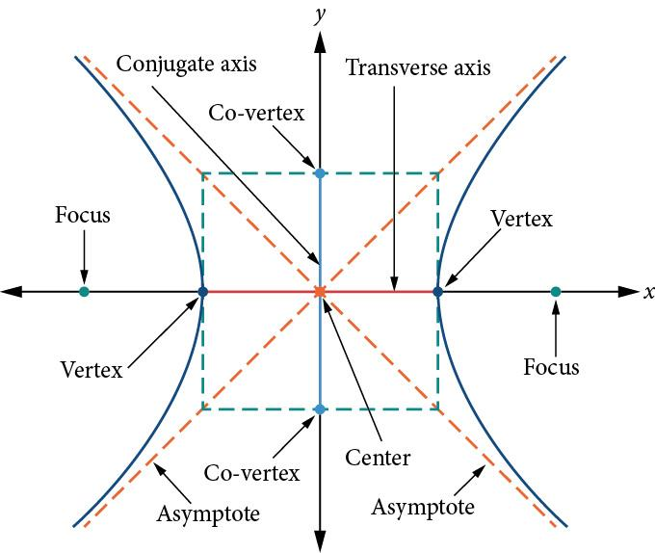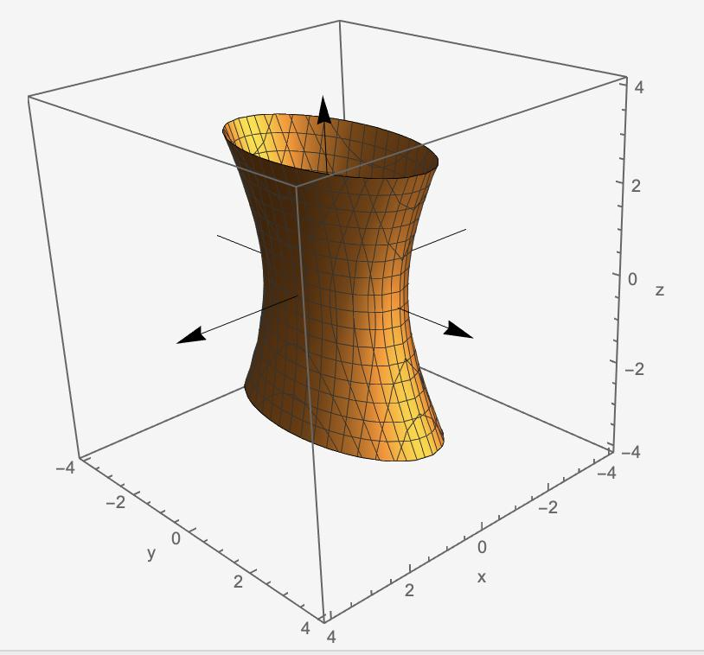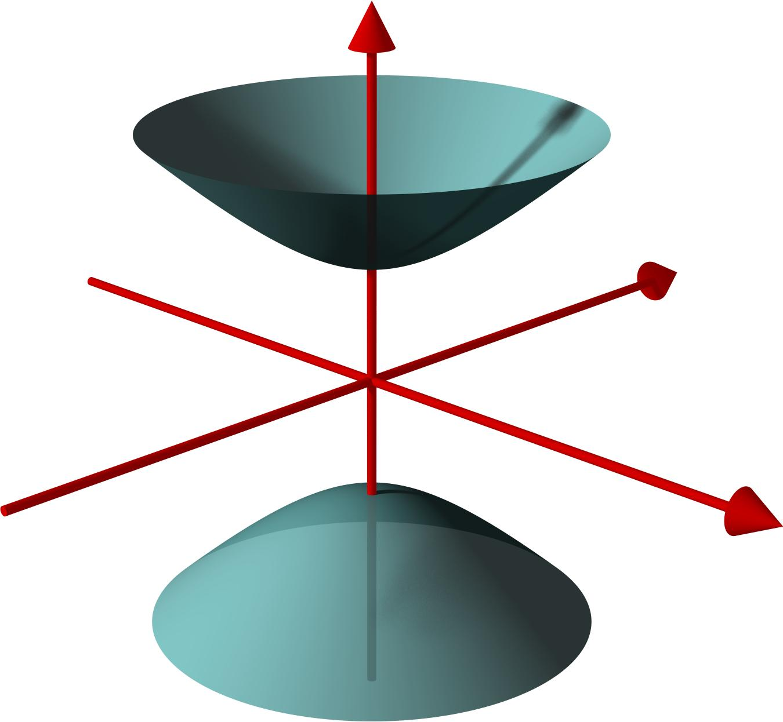
The hyperbolic curve has two separate branches that extend infinitely in opposite directions. When rotated around an appropriate axis, these branches sweep out a three-dimensional surface.

Geometric Structure
# Source: AI Source: Provided by: [Data Path: Persons Table -> ID Column: 1, Name_En Column: Motasem Essam] -> From: [ChatGPT] on [7/25/2026]
A hyperbolic-curve generator consists of the following elements:
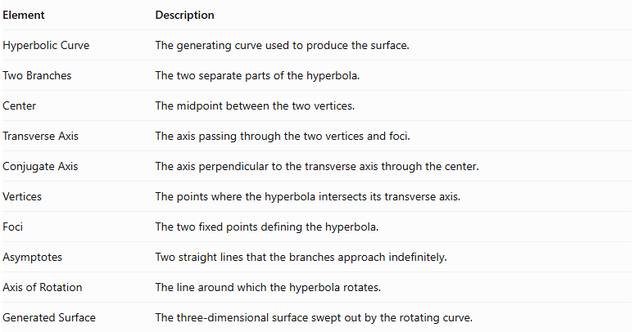
Element | Description
Hyperbolic Curve | The generating curve used to produce the surface.
Two Branches | The two separate parts of the hyperbola.
Center | The midpoint between the two vertices.
Transverse Axis | The axis passing through the two vertices and foci.
Conjugate Axis | The axis perpendicular to the transverse axis through the center.
Vertices | The points where the hyperbola intersects its transverse axis.
Foci | The two fixed points defining the hyperbola.
Asymptotes | Two straight lines that the branches approach indefinitely.
Axis of Rotation | The line around which the hyperbola rotates.
Generated Surface | The three-dimensional surface swept out by the rotating curve.

Fundamental Elements of a Hyperbola
# Source: AI Source: Provided by: [Data Path: Persons Table -> ID Column: 1, Name_En Column: Motasem Essam] -> From: [ChatGPT] on [7/25/2026]
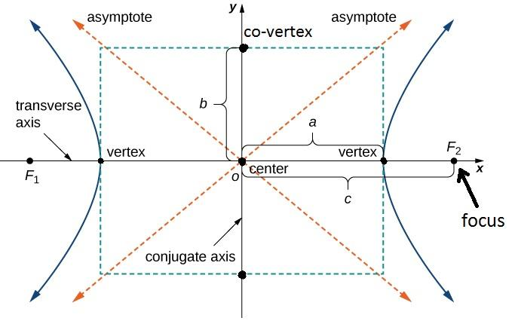
- Center: The intersection of the transverse and conjugate axes.
- Transverse Axis: The axis containing the vertices and foci.
- Conjugate Axis: The perpendicular axis through the center.
- Vertices: The two points closest to the center on the branches.
- Foci: Two fixed points used to define the hyperbola.
- Asymptotes: Lines that the branches approach as they extend toward infinity.

Types of Hyperbolic-Curve Generators According to the Axis of Rotation
# Source: AI Source: Provided by: [Data Path: Persons Table -> ID Column: 1, Name_En Column: Motasem Essam] -> From: [ChatGPT] on [7/25/2026]
The principal classification is based on which axis of the hyperbola is used for rotation.

Hyperbolic-Curve Generator Rotating Around the Conjugate Axis
# Source: AI Source: Provided by: [Data Path: Persons Table -> ID Column: 1, Name_En Column: Motasem Essam] -> From: [ChatGPT] on [7/25/2026]
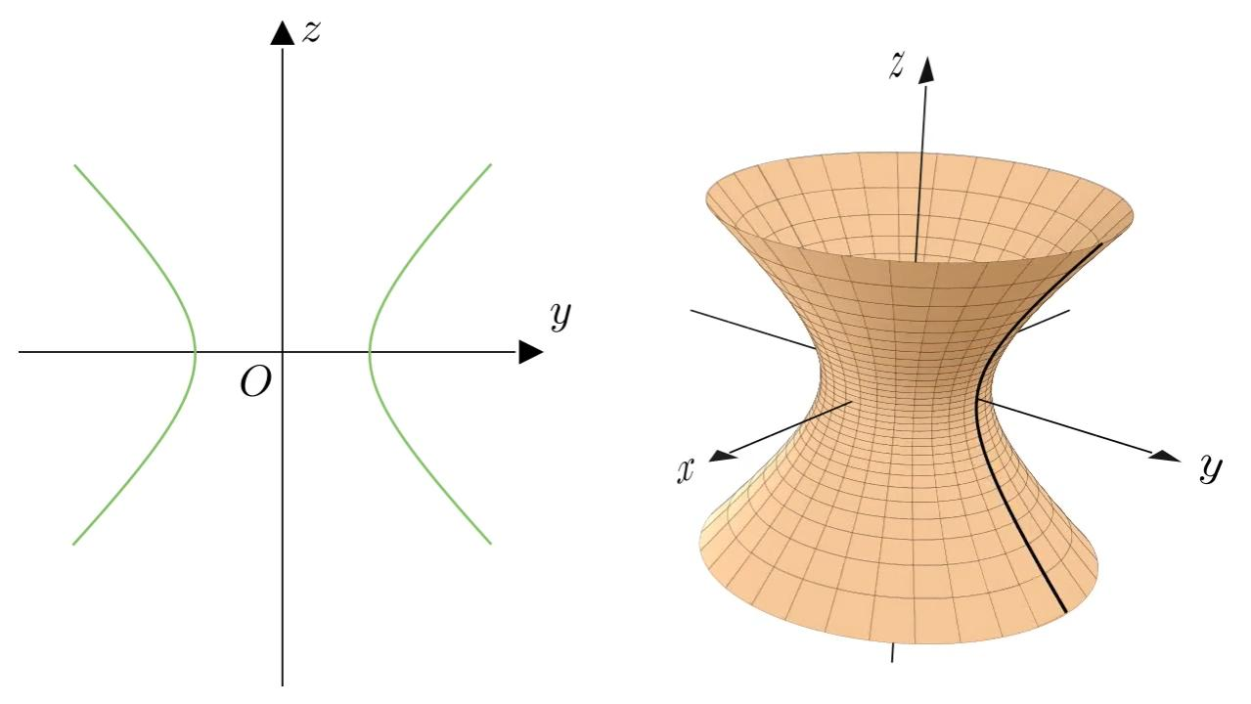
When a hyperbola rotates around its conjugate axis, it generates a:
One-Sheeted Hyperboloid (Hyperboloid of One Sheet)
Characteristics:
- Forms one continuous connected surface.
- Has a narrow central region called the waist.
- Expands outward as the distance from the center increases.
- Has circular cross-sections perpendicular to its axis of revolution.
- Has hyperbolic cross-sections through its axis of revolution.
Mathematical equation, with the axis of revolution along the $z$-axis:
$$\frac{x^{2}}{a^{2}}+\frac{y^{2}}{a^{2}}-\frac{z^{2}}{c^{2}}=1$$
Where:
- $a$ = radius of the smallest circular cross-section.
- $c$ = vertical scaling parameter.

Hyperbolic-Curve Generator Rotating Around the Transverse Axis
# Source: AI Source: Provided by: [Data Path: Persons Table -> ID Column: 1, Name_En Column: Motasem Essam] -> From: [ChatGPT] on [7/25/2026]
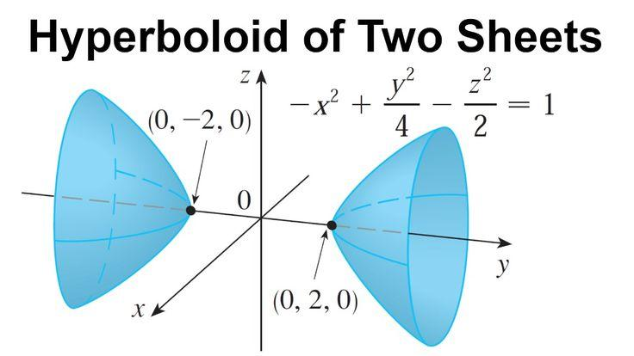
When a hyperbola rotates around its transverse axis, it generates a:
Two-Sheeted Hyperboloid (Hyperboloid of Two Sheets)
Characteristics:
- Forms two separate disconnected surface components.
- Each component extends outward from the central region.
- Has two distinct vertices along its axis of revolution.
- Has circular cross-sections perpendicular to its axis.
- Has hyperbolic cross-sections through its axis of revolution.
Mathematical equation, with the axis of revolution along the $x$-axis:
$$\frac{x^{2}}{a^{2}}-\frac{y^{2}}{c^{2}}-\frac{z^{2}}{c^{2}}=1$$
Where:
- $a$ = distance from the center to either vertex.
- $c$ = transverse scaling parameter of the circular cross-sections.

Types of Hyperbolas According to Orientation
# Source: AI Source: Provided by: [Data Path: Persons Table -> ID Column: 1, Name_En Column: Motasem Essam] -> From: [ChatGPT] on [7/25/2026]
A hyperbola can also be classified according to the direction of its transverse axis.

Type | Standard Equation | Opening Direction
Horizontal Hyperbola | $$\frac{x^{2}}{a^{2}}-\frac{y^{2}}{b^{2}}=1$$ | Left and right
Vertical Hyperbola | $$\frac{y^{2}}{a^{2}}-\frac{x^{2}}{b^{2}}=1$$ | Up and down
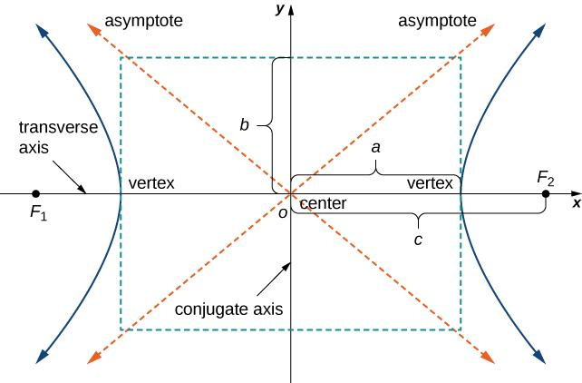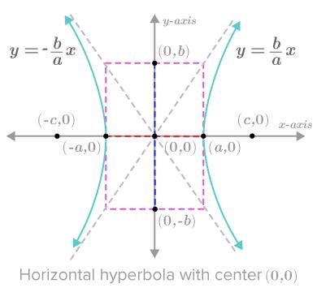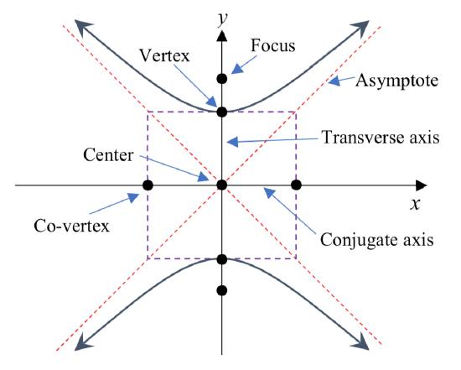
This classification describes the orientation of the generating curve, while the rotation-axis classification describes the resulting three-dimensional surface.

Mathematical Representation

Standard Equation of a Hyperbola
# Source: AI Source: Provided by: [Data Path: Persons Table -> ID Column: 1, Name_En Column: Motasem Essam] -> From: [ChatGPT] on [7/25/2026]
For a horizontal hyperbola centered at the origin:
$$\frac{x^{2}}{a^{2}}-\frac{y^{2}}{b^{2}}=1$$
For a vertical hyperbola centered at the origin:
$$\frac{y^{2}}{a^{2}}-\frac{x^{2}}{b^{2}}=1$$
The relationship between the semi-axes and focal distance is:
$$c^{2}=a^{2}+b^{2}$$
The eccentricity is:
$$e=\frac{c}{a}$$
For a hyperbola, $e>1$.

Parametric Representation
# Source: AI Source: Provided by: [Data Path: Persons Table -> ID Column: 1, Name_En Column: Motasem Essam] -> From: [ChatGPT] on [7/25/2026]
A horizontal hyperbola can be represented parametrically by:
$$x=acosht$$
$$y=bsinht$$
Where $t$ is a real parameter.
The hyperbolic functions are:
$$cosht=\frac{e^{t}+e^{-t}}{2}$$
$$sinht=\frac{e^{t}-e^{-t}}{2}$$

One-Sheeted Hyperboloid Parametric Equation
# Source: AI Source: Provided by: [Data Path: Persons Table -> ID Column: 1, Name_En Column: Motasem Essam] -> From: [ChatGPT] on [7/25/2026]
Rotating the hyperbola around its conjugate axis produces:
$$x=acoshtcosθ$$
$$y=acoshtsinθ$$
$$z=csinht$$
Where:
- $t$ controls the position along the hyperbolic profile.
- $θ$ controls the rotation around the axis.

Two-Sheeted Hyperboloid Parametric Equation
# Source: AI Source: Provided by: [Data Path: Persons Table -> ID Column: 1, Name_En Column: Motasem Essam] -> From: [ChatGPT] on [7/25/2026]
Rotating the hyperbola around its transverse axis produces two separate components:
$$x=±acosht$$
$$y=csinhtcosθ$$
$$z=csinhtsinθ$$
The positive and negative signs represent the two separate sheets.

Mathematical Properties
# Source: AI Source: Provided by: [Data Path: Persons Table -> ID Column: 1, Name_En Column: Motasem Essam] -> From: [ChatGPT] on [7/25/2026]
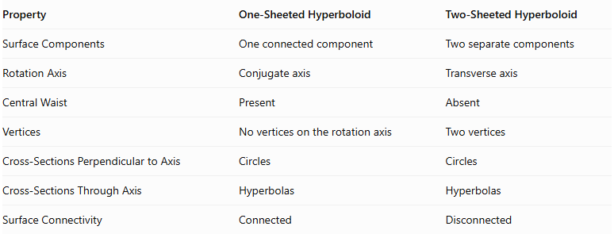
Property | One-Sheeted Hyperboloid | Two-Sheeted Hyperboloid
Surface Components | One connected component | Two separate components
Rotation Axis | Conjugate axis | Transverse axis
Central Waist | Present | Absent
Vertices | No vertices on the rotation axis | Two vertices
Cross-Sections Perpendicular to Axis | Circles | Circles
Cross-Sections Through Axis | Hyperbolas | Hyperbolas
Surface Connectivity | Connected | Disconnected

Geometric Dimensions and Formulas

One-Sheeted Hyperboloid
# Source: AI Source: Provided by: [Data Path: Persons Table -> ID Column: 1, Name_En Column: Motasem Essam] -> From: [ChatGPT] on [7/25/2026]
For a circular one-sheeted hyperboloid:
$$\frac{x^{2}+y^{2}}{a^{2}}-\frac{z^{2}}{c^{2}}=1$$
At a height $z$, the circular cross-section radius is:
$$r(z)=a\sqrt{1+\frac{z^{2}}{c^{2}}}$$
The minimum radius occurs at the center:
$$r_{min}=a$$

Two-Sheeted Hyperboloid
# Source: AI Source: Provided by: [Data Path: Persons Table -> ID Column: 1, Name_En Column: Motasem Essam] -> From: [ChatGPT] on [7/25/2026]
For a circular two-sheeted hyperboloid:
$$\frac{x^{2}}{a^{2}}-\frac{y^{2}+z^{2}}{c^{2}}=1$$
At a position $x$, the circular cross-section radius is:
$$r(x)=c\sqrt{\frac{x^{2}}{a^{2}}-1}$$
The surface exists only when:
$$|x|≥a$$
The two vertices are located at:
$$(a,0,0), (-a,0,0)$$
Note: These are unbounded surfaces. To obtain finite solids, they must be bounded by additional planes or other surfaces.

Generated Surfaces and Solids

One-Sheeted Hyperboloid
# Source: AI Source: Provided by: [Data Path: Persons Table -> ID Column: 1, Name_En Column: Motasem Essam] -> From: [ChatGPT] on [7/25/2026]
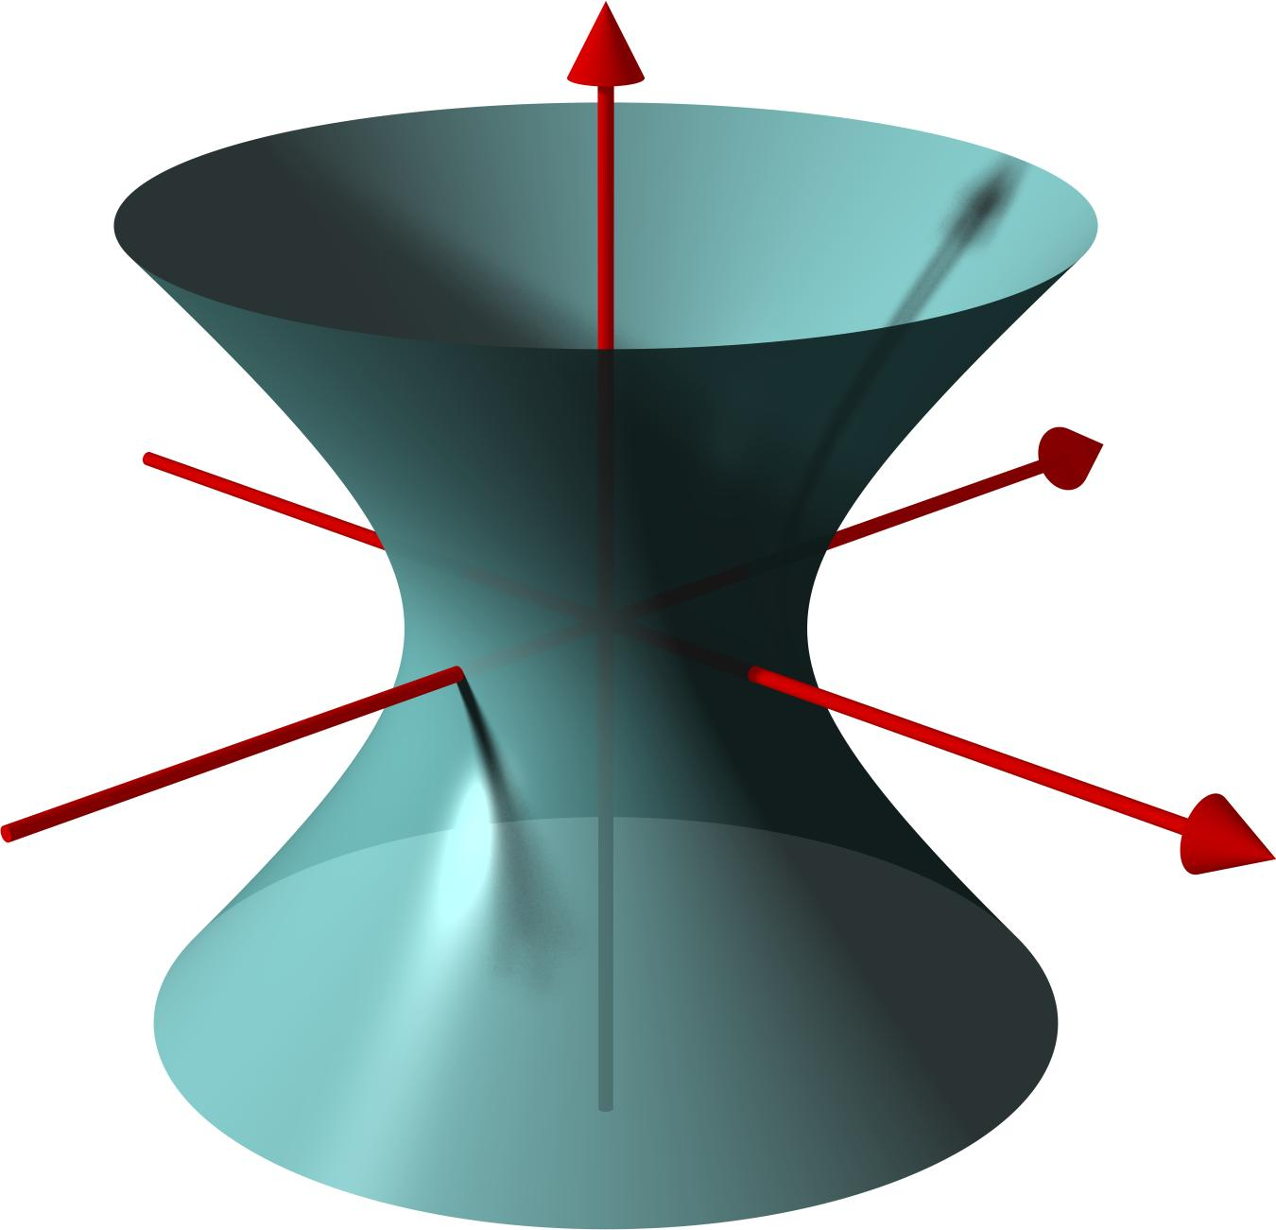
Generated by rotating a hyperbola around its conjugate axis.

Two-Sheeted Hyperboloid
# Source: AI Source: Provided by: [Data Path: Persons Table -> ID Column: 1, Name_En Column: Motasem Essam] -> From: [ChatGPT] on [7/25/2026]
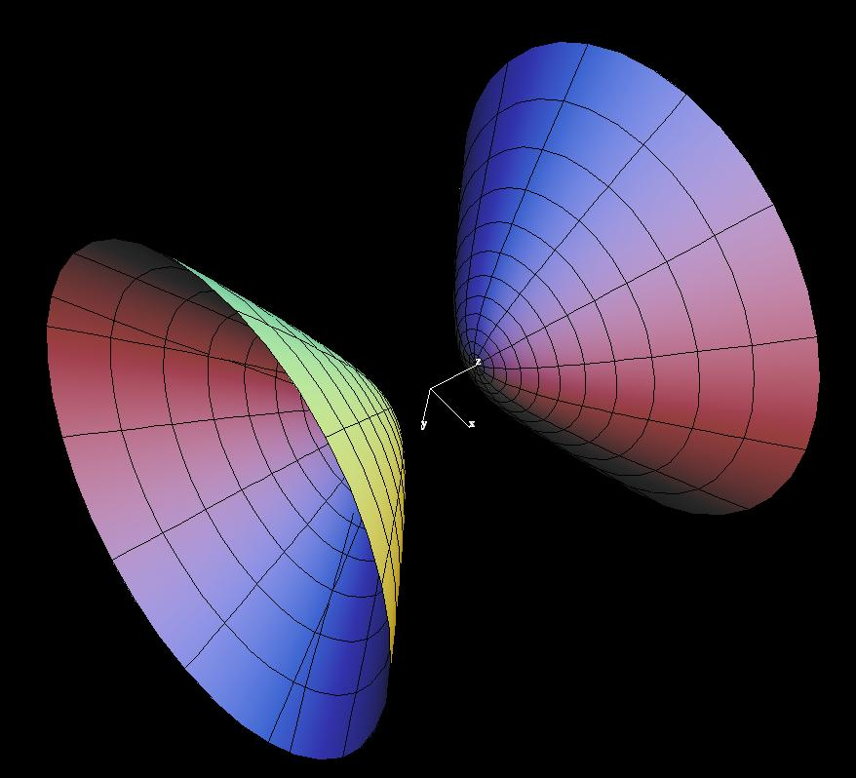
Generated by rotating a hyperbola around its transverse axis.

Hyperboloid of Revolution
# Source: AI Source: Provided by: [Data Path: Persons Table -> ID Column: 1, Name_En Column: Motasem Essam] -> From: [ChatGPT] on [7/25/2026]
A Hyperboloid of Revolution is a hyperboloid generated by rotating a hyperbola around one of its principal axes.
It includes:
- One-Sheeted Hyperboloid of Revolution.
- Two-Sheeted Hyperboloid of Revolution.
A general elliptic hyperboloid has unequal horizontal semi-axes and is not necessarily a surface of revolution.

Applications
# Source: AI Source: Provided by: [Data Path: Persons Table -> ID Column: 1, Name_En Column: Motasem Essam] -> From: [ChatGPT] on [7/25/2026]
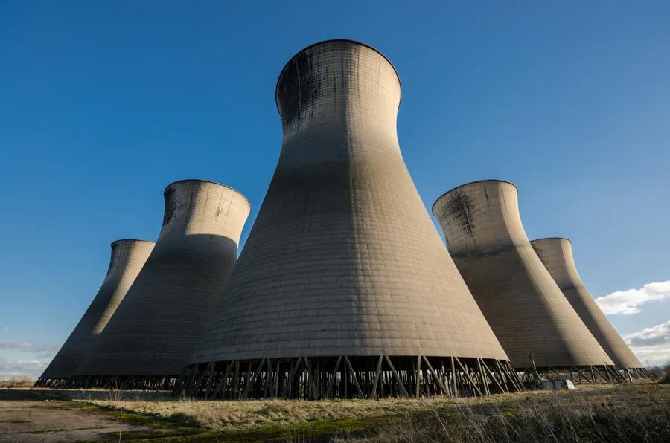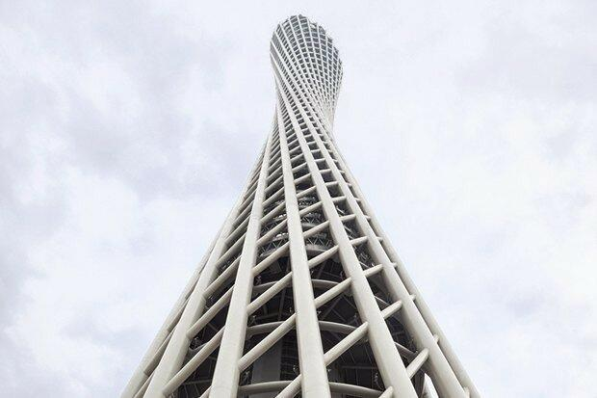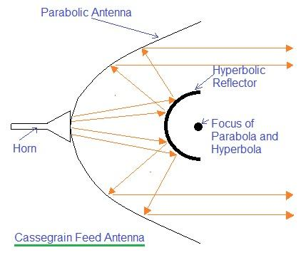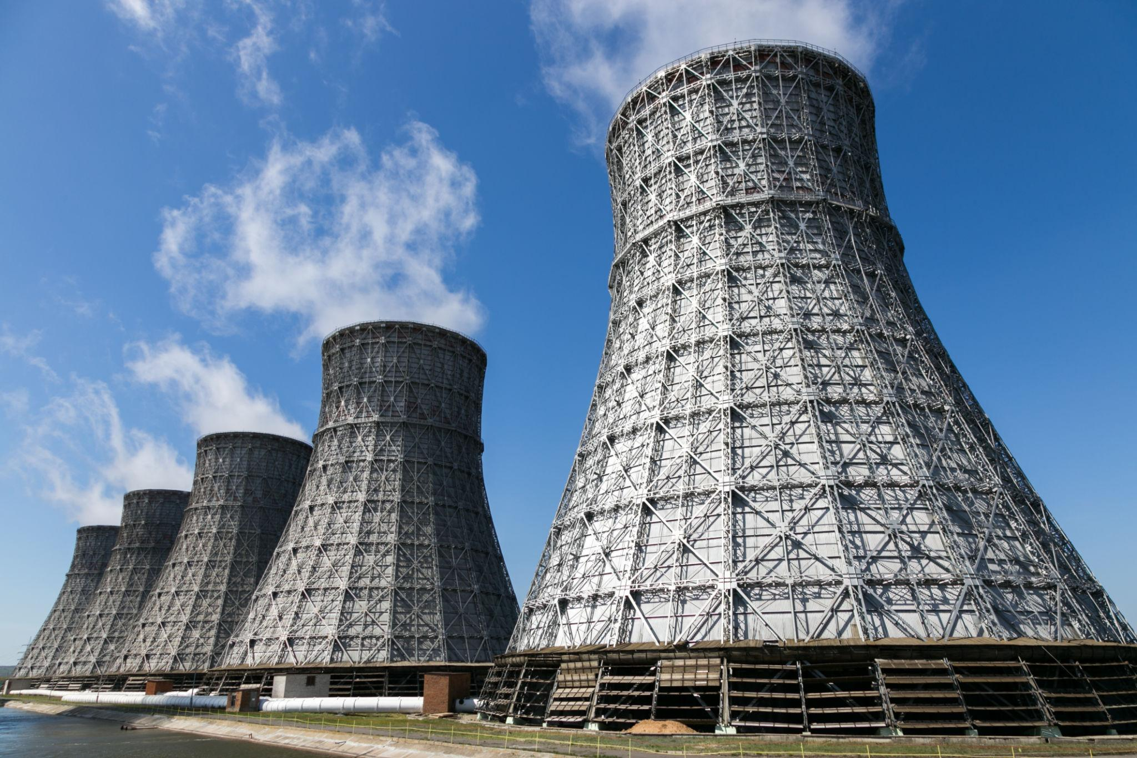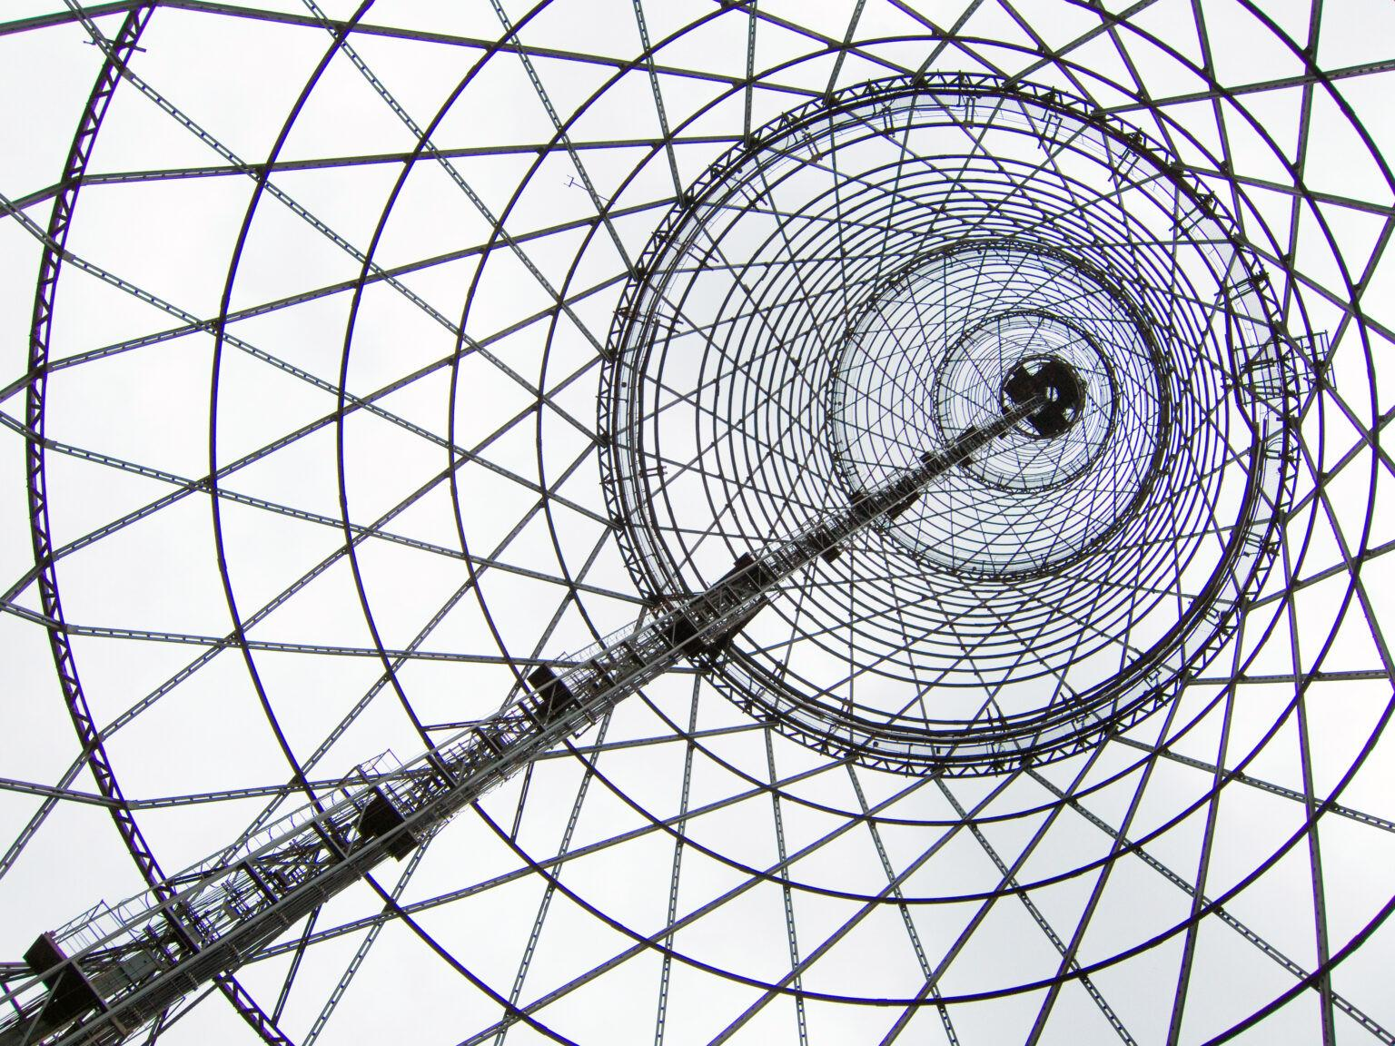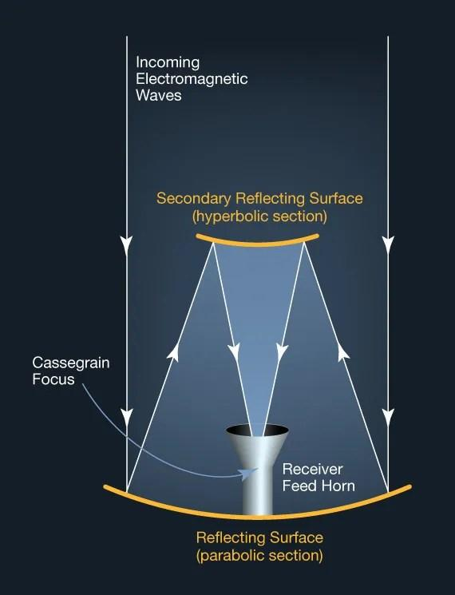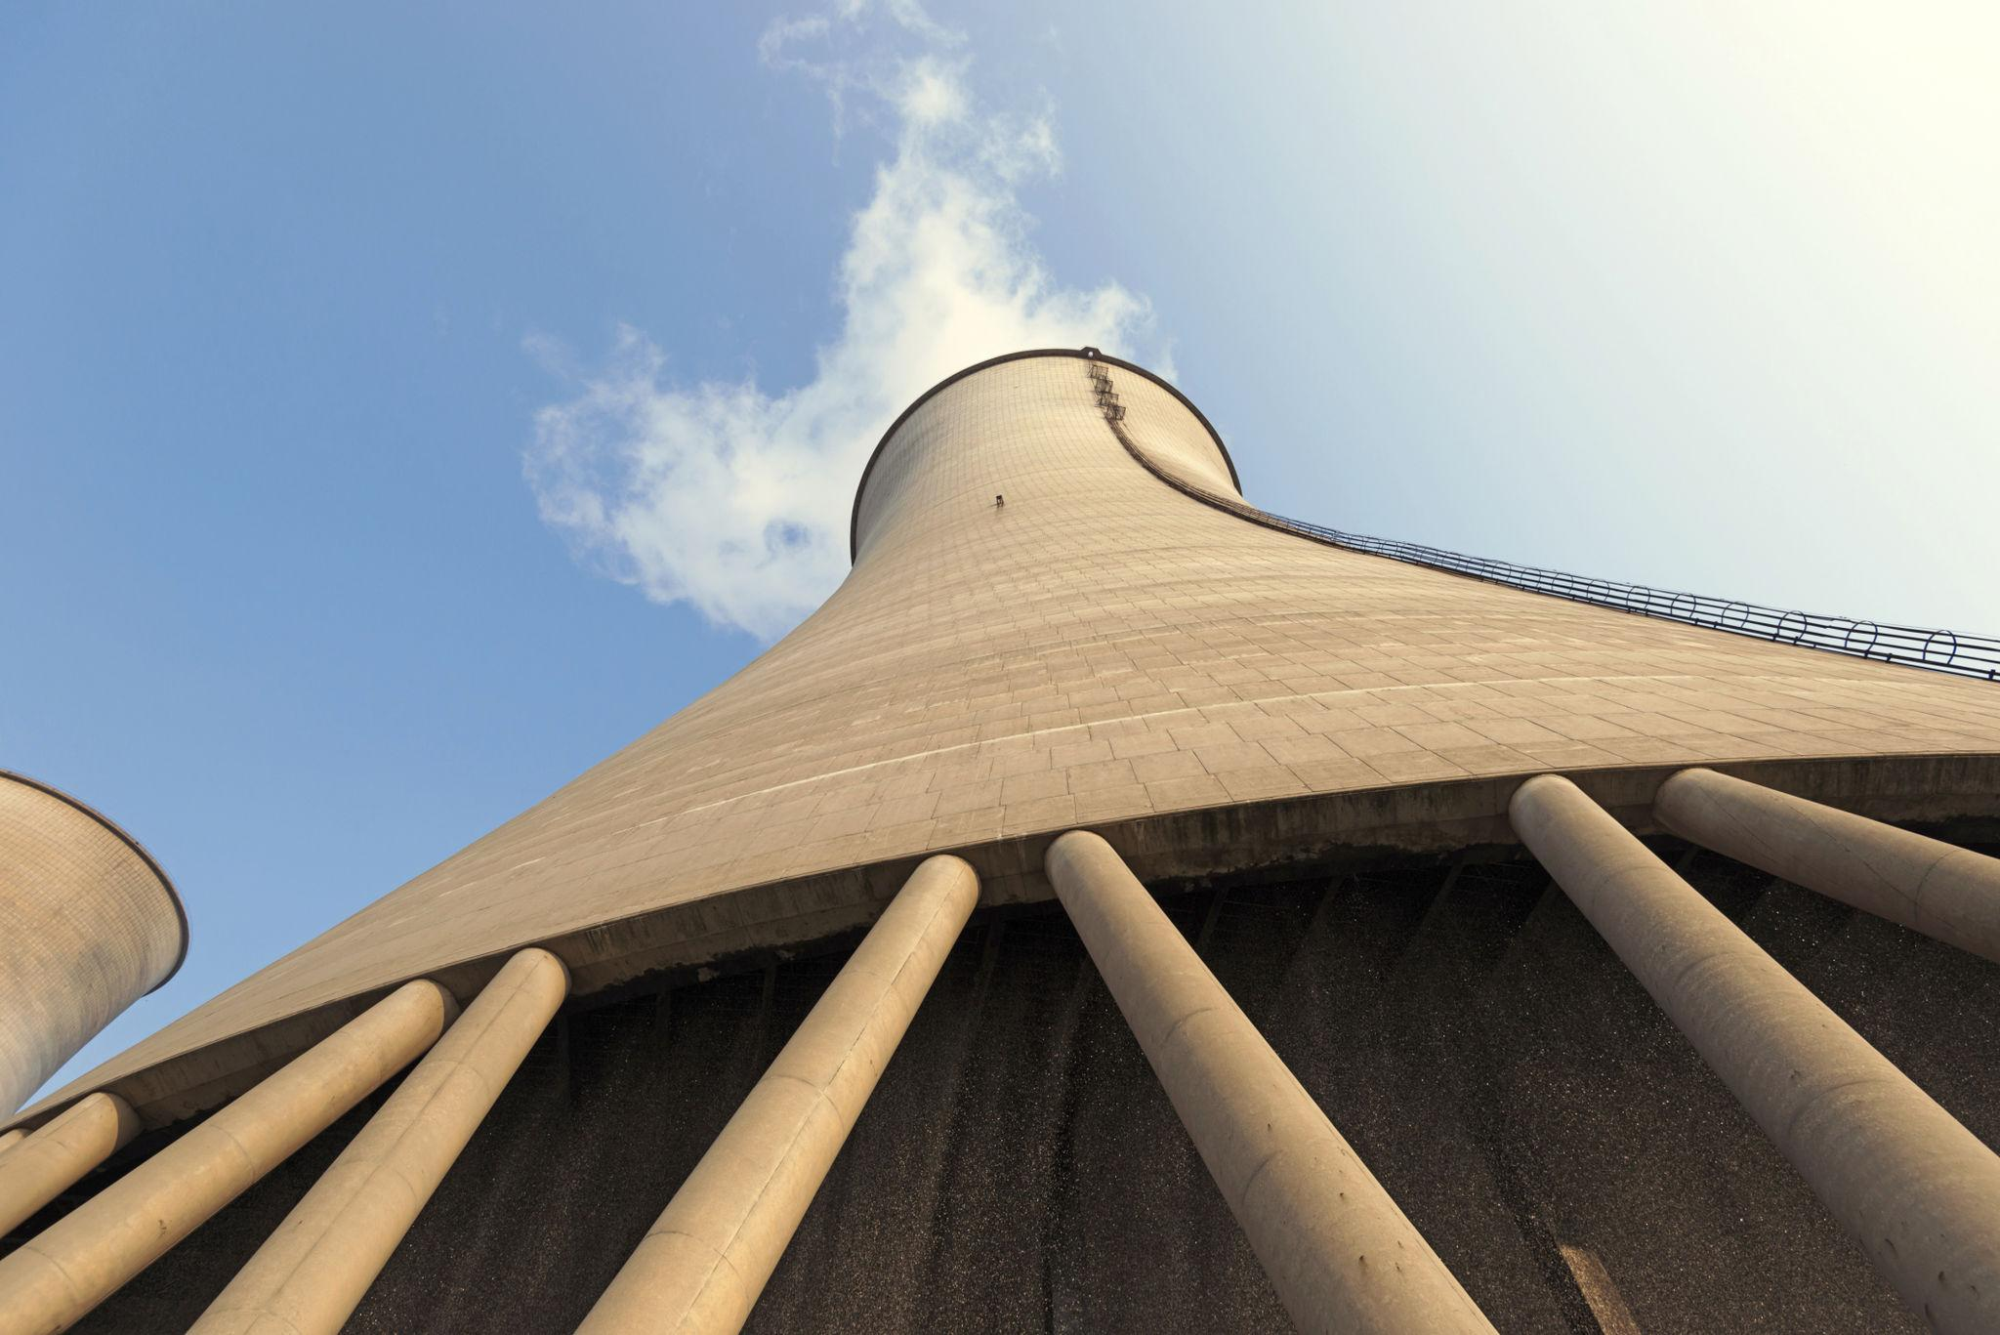
Hyperboloidal forms are used in:
- Cooling Towers: Hyperboloid-shaped structures are common in industrial cooling towers.
- Architecture: Used in distinctive structural and architectural designs.
- Engineering Structures: Used in frameworks made from straight structural members.
- Industrial Design: Used in certain mechanical and structural components.
The one-sheeted hyperboloid is especially useful in structures because it is a doubly ruled surface: it can be formed by two distinct families of straight lines.

Comparison with Other Curved-Line Generators
# Source: AI Source: Provided by: [Data Path: Persons Table -> ID Column: 1, Name_En Column: Motasem Essam] -> From: [ChatGPT] on [7/25/2026]
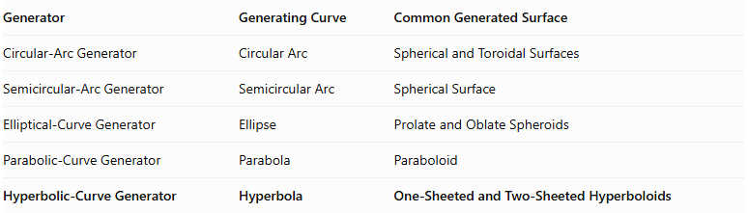
Generator | Generating Curve | Common Generated Surface
Circular-Arc Generator | Circular Arc | Spherical and Toroidal Surfaces
Semicircular-Arc Generator | Semicircular Arc | Spherical Surface
Elliptical-Curve Generator | Ellipse | Prolate and Oblate Spheroids
Parabolic-Curve Generator | Parabola | Paraboloid
Hyperbolic-Curve Generator | Hyperbola | One-Sheeted and Two-Sheeted Hyperboloids

Main Classification
# Source: AI Source: Provided by: [Data Path: Persons Table -> ID Column: 1, Name_En Column: Motasem Essam] -> From: [ChatGPT] on [7/25/2026]
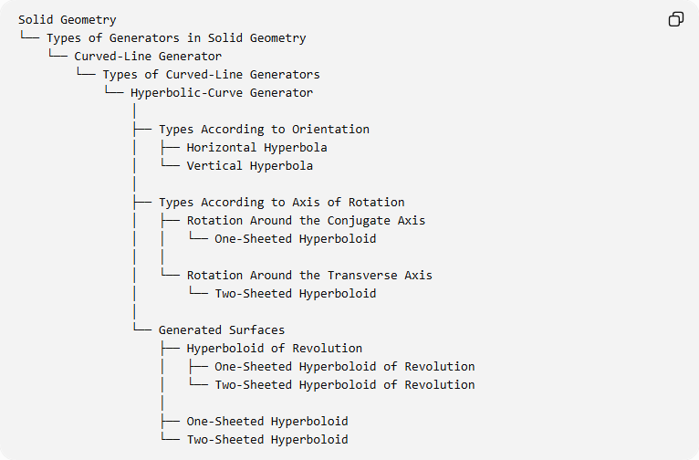
Solid Geometry
└── Types of Generators in Solid Geometry
└── Curved-Line Generator
└── Types of Curved-Line Generators
└── Hyperbolic-Curve Generator
│
├── Types According to Orientation
│ ├── Horizontal Hyperbola
│ └── Vertical Hyperbola
│
├── Types According to Axis of Rotation
│ ├── Rotation Around the Conjugate Axis
│ │ └── One-Sheeted Hyperboloid
│ │
│ └── Rotation Around the Transverse Axis
│ └── Two-Sheeted Hyperboloid
│
└── Generated Surfaces
├── Hyperboloid of Revolution
│ ├── One-Sheeted Hyperboloid of Revolution
│ └── Two-Sheeted Hyperboloid of Revolution
│
├── One-Sheeted Hyperboloid
└── Two-Sheeted Hyperboloid

Key Points
# Source: AI Source: Provided by: [Data Path: Persons Table -> ID Column: 1, Name_En Column: Motasem Essam] -> From: [ChatGPT] on [7/25/2026]
- A hyperbolic-curve generator uses a hyperbola as its generating curve.
- Rotating a hyperbola around its conjugate axis produces a one-sheeted hyperboloid.
- Rotating a hyperbola around its transverse axis produces a two-sheeted hyperboloid.
- A one-sheeted hyperboloid is connected, while a two-sheeted hyperboloid consists of two disconnected components.
- A hyperboloid of revolution has circular cross-sections perpendicular to its axis of rotation.
- The generated surfaces are unbounded unless additional boundaries are introduced.

Conclusion
# Source: AI Source: Provided by: [Data Path: Persons Table -> ID Column: 1, Name_En Column: Motasem Essam] -> From: [ChatGPT] on [7/25/2026]
The Hyperbolic-Curve Generator is an important curved-line generator in solid geometry. Its main characteristic is that the axis of rotation determines which type of hyperboloid is produced: a one-sheeted hyperboloid or a two-sheeted hyperboloid.

